

**Parent Handbook**

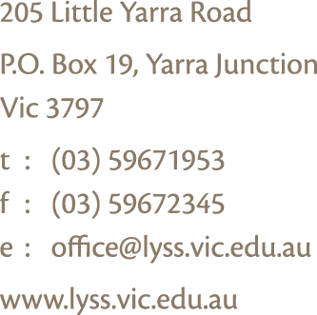**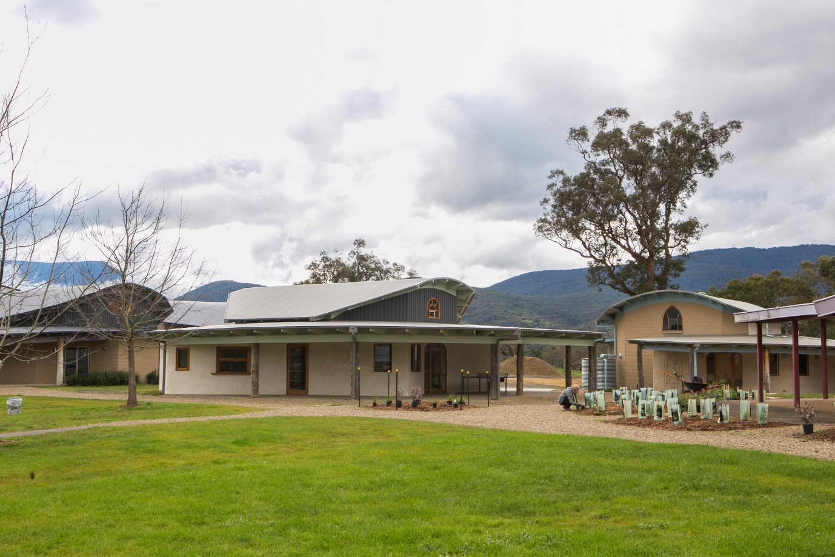**

**

*The community of the Little Yarra Steiner School is proud and pleased to welcome you and your family to our beautiful school. We wish you an enriching journey.*

*This Parent Handbook contains practical information about how we operate as a school and community. Please keep it handy for future reference, keeping in mind that changes do occur over time.*

Contents

[GENERAL ADMINISTRATION 5](#_Toc104894346)

[**The Office** 5](#_Toc104894347)

[**Preschool Program** 6](#_Toc104894348)

[7](#_Toc104894349)

[**School Hours for Classes 1-12** 8](#_Toc104894350)

[**Half Days** 8](#_Toc104894351)

[**End of Term** 8](#_Toc104894352)

[**Absences** 8](#_Toc104894353)

[**Late Arrivals and Early Departures** 8](#_Toc104894354)

[**Calling Home** 8](#_Toc104894355)

[**Mobile Phones and Electronic Devices** 8](#_Toc104894356)

[**Messages** 8](#_Toc104894357)

[**Lost Property** 8](#_Toc104894358)

[**Buses** 9](#_Toc104894359)

[**Excursions** 9](#_Toc104894360)

[**School Photos** 10](#_Toc104894361)

[**Emergency Procedures** 11](#_Toc104894362)

[HEALTH & WELLBEING 11](#_Toc104894363)

[**First Aid** 11](#_Toc104894364)

[**Food** 11](#_Toc104894365)

[**Media** 11](#_Toc104894366)

[**Clothing** 12](#_Toc104894367)

[**Classes 1-8 (Please refer to the Class 9-12 handbook for Upper School students)** 12](#_Toc104894368)

[**Sun Hats** 12](#_Toc104894369)

[**Classes 1-8 (Please refer to the Class 9-12 handbook for Upper School students)** 12](#_Toc104894370)

[AVENUES OF COMMUNICATION 12](#_Toc104894371)

[**Newsletter** 12](#_Toc104894372)

[**Internet** 12](#_Toc104894373)

[**Facebook Page** 12](#_Toc104894374)

[**Class Carers** 12](#_Toc104894375)

[**Class Meetings for Parents and Teachers** 13](#_Toc104894376)

[**Parent-Teacher Interviews** 13](#_Toc104894377)

[**School Reports** 13](#_Toc104894378)

[**Questions, Comments, Concerns** 13](#_Toc104894379)

[FEE INFORMATION 14](#_Toc104894380)

[**Fee Payments** 14](#_Toc104894381)

[**Fee Relief** 14](#_Toc104894382)

[**Conveyance Allowance** 14](#_Toc104894383)

[**Camps, Sports and Education Fund (CSEF)** 14](#_Toc104894384)

[**Tax Deductible Building Fund** 15](#_Toc104894385)

[SCHOOL STRUCTURE 15](#_Toc104894386)

[**Board of Directors** 15](#_Toc104894387)

[**Management** 15](#_Toc104894388)

[**College of Teachers** 15](#_Toc104894389)

[PARENT INVOLVEMENT 16](#_Toc104894390)

[ASSOCIATED COMMUNITY GROUPS 17](#_Toc104894391)

[**LYSS Parents’ & Friends’ Association (P&F)** 17](#_Toc104894392)

[**Fair Coordination Group** 17](#_Toc104894393)

[**Sweet Porridge** 17](#_Toc104894394)

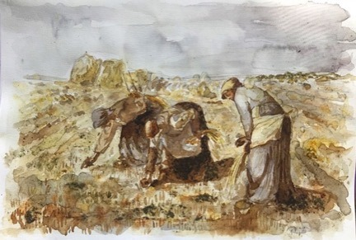

# GENERAL ADMINISTRATION

## **The Office**

The office is located in the Administration Building. Parents are most welcome to come to the office to ask questions, leave messages, make payments and gain information. You can also contact the office by phone: 5967 1953 or by email: [office@lyss.vic.edu.au](mailto:office@lyss.vic.edu.au).

The office is open from 8:30 a.m. until 4:00 p.m. Monday to Friday during school terms and from 9:00 a.m. throughout the School holidays, closing for four weeks over Christmas.

Office staff include:

|  |  |
| --- | --- |
| *Reception* | Lisa Wilson |
| *Bus Passenger Liaison & Administration Assistant* | Sonja Fischer |
| *Accounts* | Melissa Clarke |
| *Music Administration* | Sara Clarke |
| *Daily Organiser* | Carita Merilainen |
| *Registrar* | Rachel Sinclair |
| *Assistant Principal* | Bernie Wagg |
| *Business Manager* | Ross Ingram |
| *Principal* | John Stewart |
| *IT Manager* | Phillip Lemon |

**School Hours**

Please ensure students arrive at school between 8:30 a.m. and 8:45 a.m. Where children finish at 3:15 p.m. they need to collected by 3:45 p.m.

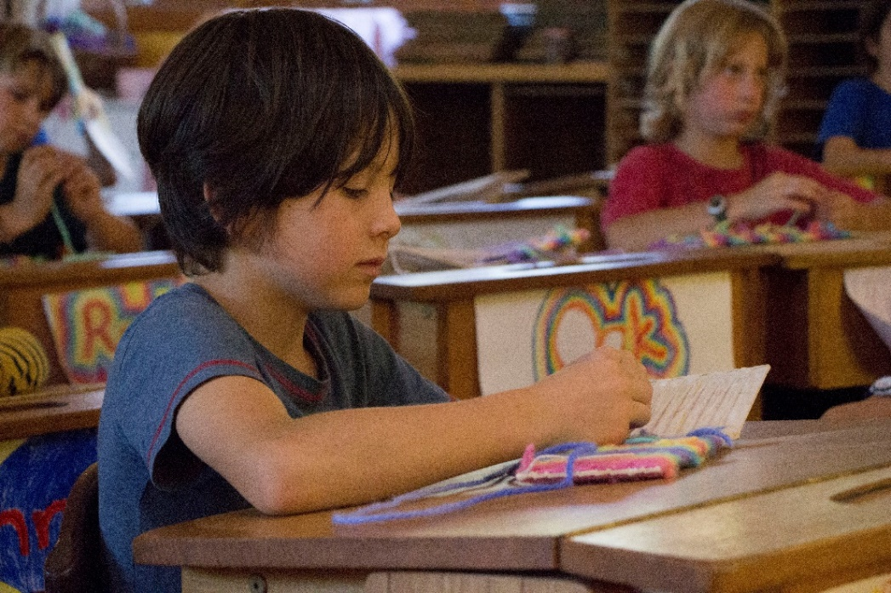

## **Preschool Program**

The Preschool spans four years: Playgroup, 3 year old Kinder, 4 year old Kinder, and Prep.

*Playgroup*

Currently playgroup runs on Monday and Wednesday mornings in the Murrum room from 9:00 a.m. – 11:00 a.m. A parent or guardian attends with the child and the group is led by Rachel Sinclair. Playgroup helps to familiarise children with the Preschool program, make connections with other children and to feel at home in the space. This helps children feel more comfortable when it comes time to go to Murrum (3yo kinder) the following year without their parent or carer.

Please contact Rachel on [rsinclair@lyss.vic.edu.au](mailto:rsinclair@lyss.vic.edu.au) if you are interested in joining.

*Murrum Kinder*

Murrum is a funded kinder program for children who are 3 years old at the beginning of the year, turning 4 throughout the year. It is held in the Murrum room three mornings per week. Children attend for two sessions each week.

Session times:

|  |  |  |  |  |  |
| --- | --- | --- | --- | --- | --- |
| **Murrum** | **Monday** | **Tuesday** | **Wednesday** | **Thursday** | **Friday** |
| Murrum Kinder (children 3 turning 4) | No Sessions | Start - 8.45am Finish - 1.00pm | No Sessions | Start - 8.45am Finish - 1.00pm | Start - 8.45am Finish - 1.00pm |

*Kinder*

This is a funded 4 year old kinder program and is held in multi-age groups with the Prep children in the Djirri Djirri and Wirrup rooms. Children in enrolled in kinder are 4 turning 5 throughout the year. Kinder children can attend either whole day or part day sessions. See timetable below:

| **Djirri Djirri & Wirrup** | **Monday** | **Tuesday** | **Wednesday** | **Thursday** | **Friday** |
| --- | --- | --- | --- | --- | --- |
| Kinder  part day sessions | Start - 8.45am Finish - 1.00pm | Start - 8.45am Finish - 1.00pm | No Sessions | Start - 8.45am Finish - 1.00pm | Start - 8.45am Finish - 1.00pm |
| Kinder  whole day sessions | Start - 8.45am Finish - 3.00pm | Start - 8.45am Finish - 3.00pm | No Sessions | Start - 8.45am Finish - 3.00pm | Start - 8.45am Finish - 3.00pm |

*Prep*

Prep children attend 5 whole days from Semester 1. Prep forms part of the multi-age group with Kinder children in the Djirri Djirri & Wirrup rooms. An exclusive program for the Prep children operates on Wednesdays.

|  |  |  |  |  |  |
| --- | --- | --- | --- | --- | --- |
| **Djirri Djirri & Wirrup** | **Monday** | **Tuesday** | **Wednesday** | **Thursday** | **Friday** |
| Prep (children 5 turning 6) | Start - 8.45am Finish - 3.00pm | Start - 8.45am Finish - 3.00pm | Start –  8.45am  Finish - 3.00pm | Start - 8.45am Finish - 3.00pm | Start - 8.45am Finish - 3.00pm |

## \\lyss-fs2\home\jmclachlan\My Pictures\40787_1311544400653_4368951_n.jpg

## **School Hours for Classes 1-12**

|  |  |
| --- | --- |
| *Start* | 8:45 a.m. |
| *Finish* | 3:15 p.m. |
| \*Class 1 students finish at 12:30 p.m. on Wednesdays; VCE classes may finish at 4:00 p.m. | |

## **Half Days**

At the start of each year the children are introduced slowly to the Preschool and Class 1. Depending on the need of the class there may be a period of half day sessions over the first few weeks of school. This will be determined by the school at the time and communicated to parents by letter before the start of the year. Please also note that Class 1 students finish at 12:30 p.m. on Wednesdays all year.

## **End of Term**

Preschool: The last day of each term is a half day with a finish time of 12:30 p.m.

Class 1 to Class 12: Term 1 finishes at 3:15 p.m. and the last day of Term 2, 3 & 4 is a half day with a finish time of 12:30 p.m. Please note: Occasionally these times may vary. Please keep an eye on the newsletter for accurate up to date information on dates and times.

**Absences**

If you have prior knowledge of an absence from school please ensure that the office or the Class Teacher/Class Guardian knows as soon as possible. If your child is ill or unexpectedly absent then please phone the office and leave a message, send an email notification to [office@lyss.vic.edu.au](mailto:office@lyss.vic.edu.au) or you can text the school on 0438 814 170.

When a child’s whereabouts is unknown to the teacher, a notice will be sent to the office and we will contact you by SMS text message if we have not heard from you already.

## **Late Arrivals and Early Departures**

If you and/or your child are running late, please come to the office and we will mark your child as present and provide them with a late slip for their teacher. Any student leaving School during school hours must be signed out at the office by a parent or guardian. If your child returns to school on the same day, you need to come to the office to sign your child back in.

## **Calling Home**

Students will need permission from their Class Teacher or Guardian to use the phone in the office. Staff in the office will give access to a phone for emergencies such as medication being left at home, providing students come with a note from their teacher.

## **Mobile Phones and Electronic Devices**

In an effort to maintain a calm and unhurried environment we ask that while on school grounds parents keep mobile phones and electronic devices out of view of children.

## **Messages**

The office staff makes every effort to deliver *emergency* messages to students and staff. Non-emergency messages will be left at the office for collection by students or placed in their teacher’s pigeon hole, (whichever suits the circumstance).

## **Lost Property**

Please label your children’s clothing. If your child loses an item of clothing, there are baskets located in both the class foyers and in the Administration building. Please retrieve lost clothing before the end of each term as all unclaimed items may be sold for fundraising purposes or donated to charity.

***Dropping Off on the School Grounds***

The speed limit within the school grounds is 10 km/hr.

If you need to park your car, please use the car park which is located to your immediate right as you enter the School. To maintain children’s safety please walk on the pathways.

Drop-off zones exist as you enter the School in the sign-posted areas around the small round-a-bout. Please minimise the time spent in the drop off zone to enable other parents to have similar access.

Beyond the drop-off zone is staff parking, with the exception of disabled parking bays as designated.

## **Buses**

We have four private school buses, which travel from Mt Evelyn, Cockatoo/Belgrave, Healesville and East Warburton. They arrive at 8:35 a.m. and depart at 3:25 p.m. If you would like to access any of these services please see the office staff or email Sonja on [sfischer@lyss.vic.edu.au](mailto:sfischer@lyss.vic.edu.au). These services are available for students from Class 1 to 12.

Little Yarra also links in with the bus service provided to Upper Yarra Secondary College (UYSC), which connects to buses to Powelltown and Hoddles Creek.

## **Excursions**

Organised excursions are integral to our educational programs and require parents or guardians to sign a Consent Form: Excursions and Camps at the beginning of the year as part of their enrolment update. Forthcoming excursions are listed on our website and Newsletter calendar, as well as information sent home with the students.

## **School Photos**

**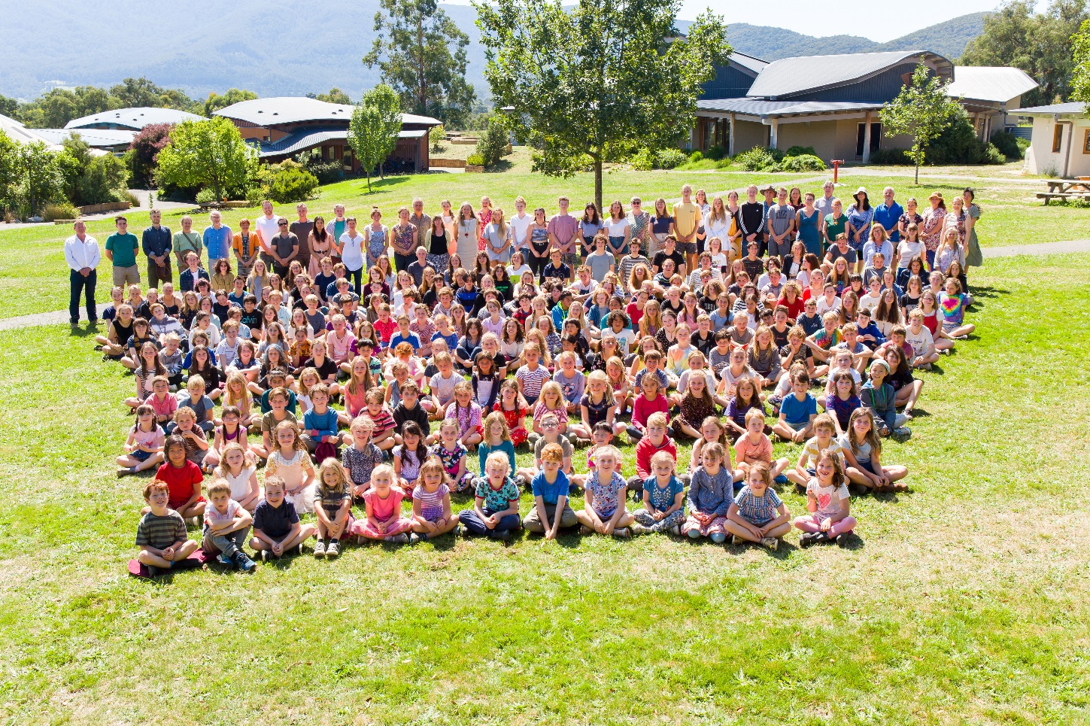**Little Yarra engages a professional photographer to come to the School each year and take class, individual, family and whole school photos. Forms are sent home via the students and these, along with payments, need to be returned to the office before the photographers arrive. The dates for photos are communicated through the newsletter.

## **Emergency Procedures**

In the event that the School is not open to students (for example on Extreme or Code Red fire danger days) the school will communicate such closures via the school’s website and, if known in advance, in the Newsletter. Please ensure your contact details are up-to-date with the school.

***Policies and Procedures***

School policies and procedures are regularly updated and, where relevant, communicated through the school website and/or newsletter. Copies of policies can also be provided by the office on request. The School is required to have a Parent Code of Conduct, amongst other policies, as stipulated by regulation. This is published on the school website.

# HEALTH & WELLBEING

## **First Aid**

The first aid room is located to the right of the foyer as you go into the Administration building. If a child requires paracetamol or ibuprofen this may be administered with written consent of the parent/guardian. This permission is collected from the Student Health and Medical Form at the time of enrolment and then at the beginning of each year with the annual enrolment update. All treatment is recorded by first aid staff. Homeopathic remedies may also be used to supplement first aid. Ambulance cover is recommended for families not covered by private health insurance, a Health Care Card or Pension Card.

## **Food**

Morning tea and afternoon tea for Preschool students (Playgroup to Prep) are provided. Meals prepared in the Preschool are made from biodynamic and/or organic produce where possible. Please confer with your child’s teacher where there are food allergies or sensitivities. Preschool children are required to bring a packed lunch from home. We encourage parents to provide healthy, well balanced nutritious lunches with limited packaged and processed food.

In Class 1 to Class 12 we encourage parents to provide their children with healthy, well-balanced lunches and avoid processed and packaged items. Healthy, well-balanced lunches promote good eating habits and nourish the children in a way that supports them for the whole day. The school does not have a canteen, as such, students will need to provide their own lunch each day.

## **Media**

Steiner education advises against the use of electronic media in young children’s lives. Children without media influences benefit greatly both in the short and long term. In the classroom these children tend to exhibit a wholesome interest in their work, show considerable will to engage in activities and, most importantly, retain those most vital powers of childhood – wonder and imagination. This puts them in good stead for intellectual learning in later years.

## **Clothing**

## **Classes 1-8 (Please refer to the Class 9-12 handbook for Upper School students)**

Appropriate dress for school is clothing that is tidy, clean and comfortable – multi-layered and warm in winter, and cool in summer (while allowing for the fluctuating temperatures in the Yarra Valley). When outside, primary aged students must wear shoes or sandals at all times. Clothing is to be plain and without advertising, slogans or sharp images. Bare midriffs, excessive jewelry, radical hairstyles or makeup are not permitted. Clothing made of natural fibers is recommended.

## **Sun Hats**

## **Classes 1-8 (Please refer to the Class 9-12 handbook for Upper School students)**

Sun hats are expected to be worn outside every day in Term 1 and Term 4. In Preschool (Ring-a-Rosy) and Class Teacher period (in Class 1 & 5) hats are supplied by the school and included in the school fees. Should a student need a replacement during this time, it will be included as sundries on your school account.

# AVENUES OF COMMUNICATION

## **Newsletter**

Little Yarra publishes a weekly newsletter containing School news and events. As a parent you will automatically receive the newsletter by email, however you can also sign up through our Newsletter page: <https://lyss.vic.edu.au/parents-community/newsletter/> with an alternative email address.

This is our preferred method of distribution as it gives you immediate access to current information. Hard copies are also available at reception on request.

## **Internet**

Little Yarra communicates many aspects of School life through its website: [www.lyss.vic.edu.au](http://www.lyss.vic.edu.au)

## **Facebook Page**

The school also has a Facebook page - <https://www.facebook.com/Little-Yarra-Steiner-School-and-Kindergarten-111373398923800/>, which you are invited to follow. Although the Newsletter is our primary form of communication, upcoming events are occasionally also advertised on our Facebook page.

## **Class Carers**

Class Carers are members of the parent body who volunteer to support the Class Teacher. They help welcome new families entering the School, support those in need, make sure practical tasks like washing is done and fresh flowers arrive for the classroom. They also assist in communicating to the class from the teacher primarily via text message and email.

## **Class Meetings for Parents and Teachers**

Class meetings are conducted for all classes from Preschool to Class 12. The parents of each class usually meet with their child’s Class Teacher or Guardian three times per year. Class meetings are an opportunity for the parents of the class to gather with the Class Teacher for an informative evening and meet with other parents in the class. During Terms 1 & 3, when parent-teacher interviews occur, class meetings may not be held.

In the Preschool and Class Teacher period, class meetings are conducted by the Class Teacher and in the Upper School by the Guardians. Class meetings are an essential part of the School’s educational philosophy and it is vital that each child is represented by at least one parent at each meeting.

In Class meetings the Class Teacher gives an overview of the consciousness of the child at their particular age, what curriculum has and will be presented, and how this relates to the development of the child. Any other items of interest are also brought by the Teacher. There is time for a hot drink and chat with other parents in the class. Class meetings are a wonderful chance to foster a sense of community within the class parent-body, develop a stronger relationship with the Class Teacher, and learn more about your child and his/her education.

The dates for class meetings are published in the school Newsletter.

## **Parent-Teacher Interviews**

Parent-Teacher interviews are individual interviews held in Term 1 for parents of Class 1 to Class 8 and in Terms 1 & 3 for parents in Classes 9 – 12. Interviews are conducted by the Class Teacher for Class 1 to Class 8 and with the Subject Teachers in the Upper School. Parents will receive communication from the school via the newsletter and book interviews with the relevant teacher/s online.

## **School Reports**

Parents of students from Prep to Class 12 receive two reports per year – one at the end of each semester. These are emailed to parents.

## **Questions, Comments, Concerns**

If you have a question, comment, or concern about your child, please discuss this with your child’s Class Teacher or Guardian. It is important to make a time with them to discuss the matter privately. If the situation does not reach a satisfactory outcome with the teacher please seek out the appropriate member of Management.

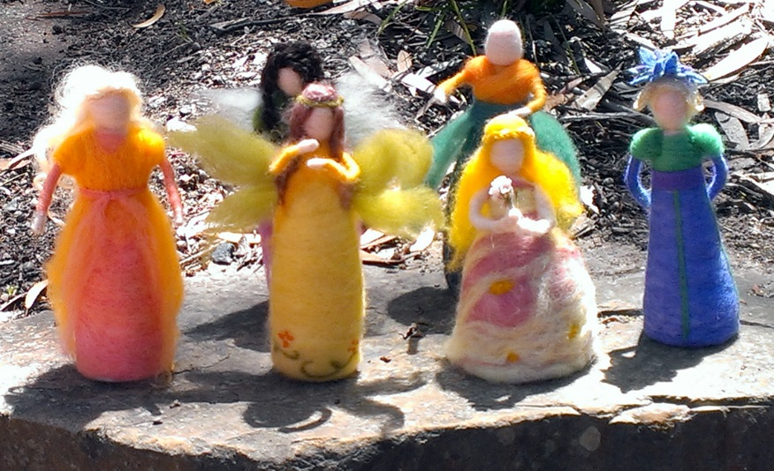

# FEE INFORMATION

## **Fee Payments**

Term statements are sent by email, if an email address has been provided to the school, or by post each term and are due within 14 days of receipt. Fees may be paid in person at the office by cash, cheque or EFTPOS. Credit card payments can be taken over the phone. Please talk to our accounts department, should you wish to pay by automatic periodic payments from your debit card. Should you wish to pay using direct debit, the School’s account details are Name: LYSS; Bank: Bendigo Bank; BSB: 633 000; Account number: 131 415 010; Reference: Your family code/name.

## **Fee Relief**

Under some circumstances the school will make a temporary reduction in fees where a family, already established at the school, is experiencing unusual and short term financial hardship. Enquiries about fee relief should be directed to the Business Manager.

## **Conveyance Allowance**

The conveyance allowance is a form of financial assistance to help families in rural and regional Victoria with the cost of transporting their children to their nearest appropriate school/campus.  
The conveyance allowance is available to eligible students travelling by private car or by school bus.

To be eligible students must

* attend their nearest government or non-government school/campus appropriate to their year level at which admission is permissible
* be enrolled at a school/campus outside Melbourne’s metropolitan conveyance boundary
* reside 4.8km or more by the shortest practicable route from that school/campus attended
* be of school age (attending Prep to Class 12) and reside in Victoria

Application forms are available from the School office.  Previous applications are carried forward providing that all details remain correct. Please fill in a fresh form if your address details have changed or you are adding an extra child to your claim.

## **Camps, Sports and Education Fund (CSEF)**

The government offers an annual subsidy to all Health Care or Pensioner Concession Card holders with school aged children (from Prep to Class 12) called the CSEF. Primary school students (Prep – 6) will receive $125 off their school fees and Secondary students will receive $225 off their fees.

If you are a Health Care or Pensioner Concession Card holder, please contact the office for a form.

***Exit Procedure***

If you withdraw your child from the School before he or she graduates from Class 12 the School requires one term’s written notice in advance. Notice includes submitting an Exit Form to the school. This form is available from the front office or the Registrar. Where eligible, bonds are refunded in full provided all fees have been paid and there are no outstanding accounts due to the School.

As part of the exit procedure the school encourages families to share feedback through the exit form.

## **Tax Deductible Building Fund**

We have a Tax Deductible Building Fund to which parents and friends of the school are able to claim a tax deduction for all donations of $2 or more to this fund. Please be in touch with our Business Manager, Leanne Sarah on [lsarah@lyss.vic.edu.au](mailto:lsarah@lyss.vic.edu.au) or on (03) 5967 1953 if you would like to make a donation to the school.

# SCHOOL STRUCTURE

## **Board of Directors**

Little Yarra Steiner School is governed by a Board of Directors. The Board has legal responsibility of the School. Members of the board are:

|  |  |  |
| --- | --- | --- |
| *Maria Brouwers* *(Chair)* | *John Stewart* (*ex-officio*) | *Tessa Priest (ex-officio)* |
| *Damien Callan* | *Ross Ingram* (*ex-officio*) | *Pauline Lucas* |
| *Ric Butler* |  |  |

## **Management**

Day-to-day management of the School is the responsibility of the members of Management. Their respective responsibilities are:

|  |  |  |
| --- | --- | --- |
| John Stewart  *Principal*  [jstewart@lyss.vic.edu.au](mailto:jstewart@lyss.vic.edu.au) | Tessa Priest  *College Chair*  tpriest@lyss.vic.edu.au | Bernie Wagg  *Chair of Management* [bwagg@lyss.vic.edu.au](mailto:bwagg@lyss.vic.edu.au) |
| Ross Ingram  *Business Manager*  [ringram@lyss.vic.edu.au](mailto:ringram@lyss.vic.edu.au) | Damien Callan  *Management Member*  [dcallan@lyss.vic.edu.au](mailto:dcallan@lyss.vic.edu.au) | Dani Fischer  *Management Member*  [dfischer@lyss.vic.edu.au](mailto:dfischer@lyss.vic.edu.au) |
| Rachel Mager  *Management Member*  [rmager@lyss.vic.edu.au](mailto:rmager@lyss.vic.edu.au) |  |  |

## **College of Teachers**

The College of Teachers is a standing committee of the Board and holds the Anthroposophical impulse of the school. Steiner describes the teachers’ meeting in this collegiate form as: “The real purpose of the teachers’ meetings is to study human development, so that a real knowledge of human beings is continually flowing through the school. The whole school is the concern of the teachers in their meetings, and all else that is needed will follow of itself. The essential thing is that in the teachers’ meetings there is study – steady, continual study.” *The Kingdom of Childhood*

# PARENT INVOLVEMENT

There are many areas of the School that need extra input and help, and we are always grateful for volunteers. Joining in on various parent activities is also a wonderful way to get to know other parents and the School.

In regards to supporting your child’s class directly, your Class Carer will be able to guide you in how you can best do this. Tasks may include helping with knitting, craft, reading and walks. Taking on the role of Class Carer may be another way you are able support the class.

The annual event in the school calendar that involves the whole school community is the Open Day and Fair, which takes place in November. It is supported by volunteer work from the parent body. The school communicates events via the weekly Newsletter and is grateful for the help and support of all parents able to help out on the day.

The ‘Associated Community Groups’ section (opposite page) also provides various ways in which you can support the School.

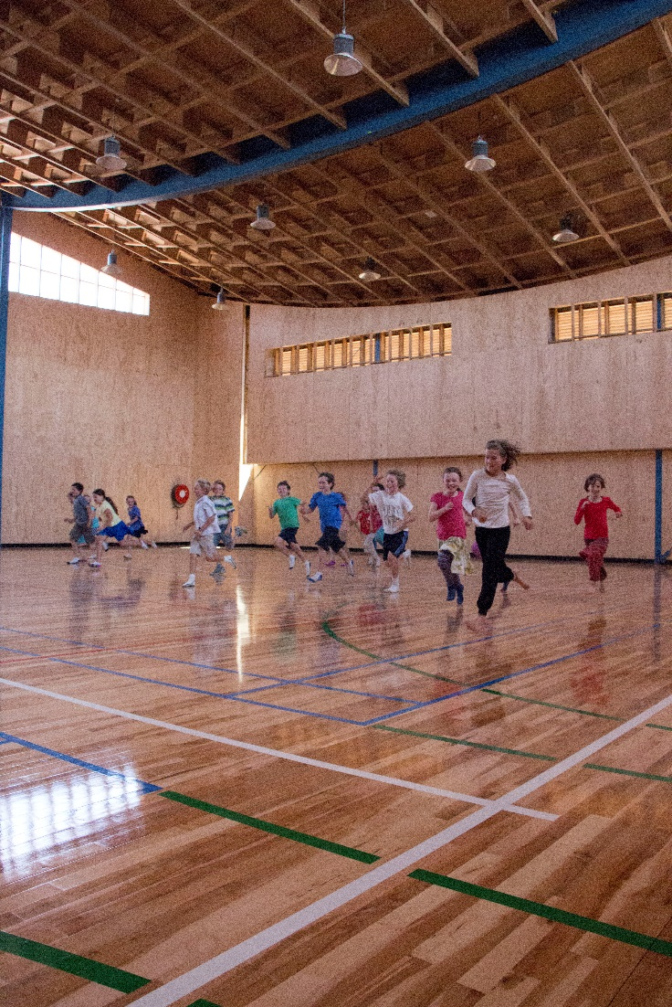

# ASSOCIATED COMMUNITY GROUPS

Below is a list of Community Groups of which you may wish to be a part.

## **LYSS Parents’ & Friends’ Association (P&F)**

The LYSS P&F represents all members of the School community working together cooperatively to support the School and to build a vibrant and effective community culture. Information about meetings can be found in the calendar of the newsletter. You can also contact the P&F at [pandf@lyss.vic.edu.au](mailto:pandf@lyss.vic.edu.au)

## **Fair Coordination Group**

The Fair Coordination Group is made up of parent volunteers, administration and maintenance staff. This group coordinates and oversees the Fair component of the annual Fair and Open Day. If you have an interest in this area contact the school office on [office@lyss.vic.edu.au](mailto:office@lyss.vic.edu.au)

***Craft Group***

In the past, the school has had a Craft Group, which met in the Admin Building on Thursday mornings 9:00 a.m. – 12:00 p.m. The group did a variety of craft activities, sharing their skills and passion for craft, with children in attendance. Should you wish to restart Craft Group, as a parent initiative, please speak with front office or email [office@lyss.vic.edu.au](mailto:office@lyss.vic.edu.au).

## **Sweet Porridge**

Sweet Porridge is Little Yarra’s parent and community newsletter. It is published at least twice a term. It provides adult education and an avenue of communication. Appropriate editorial and advertising content is welcome. Email: [sweetporridge@lyss.vic.edu.au](mailto:sweetporridge@lyss.vic.edu.au).

